Alyssa Schaefer

CS 3380: Introduction to Databases & Information Systems

Dr. Praveen Rao

February 28, 2024

Final Project: Phase 1

1. Problem Statement: I plan to build a database system that contains user information for a website. The website will serve as a virtual planner and will include a calendar feature, but it will be designed specifically for students. Therefore, it will include attributes such as the classes a student is taking and the assignments they have. The database for this project is essential because there will be a large amount of data that will dynamically alter the page depending on who the user is and what their schedule looks like. A database system is a much better alternative to storing user information in a file, as it is extremely efficient in comparison and efficiency is important to make sure the page does not take a long time to render.
2. Conceptual Database Design:

This design stores information about students, the schools they go to, their courses and assignments for those courses, and the professors that teach them.

Assumptions:  
1. All classes are taught by exactly one professor.

2. Not all student users have added courses to their schedule.

3. All student users go to exactly one school.

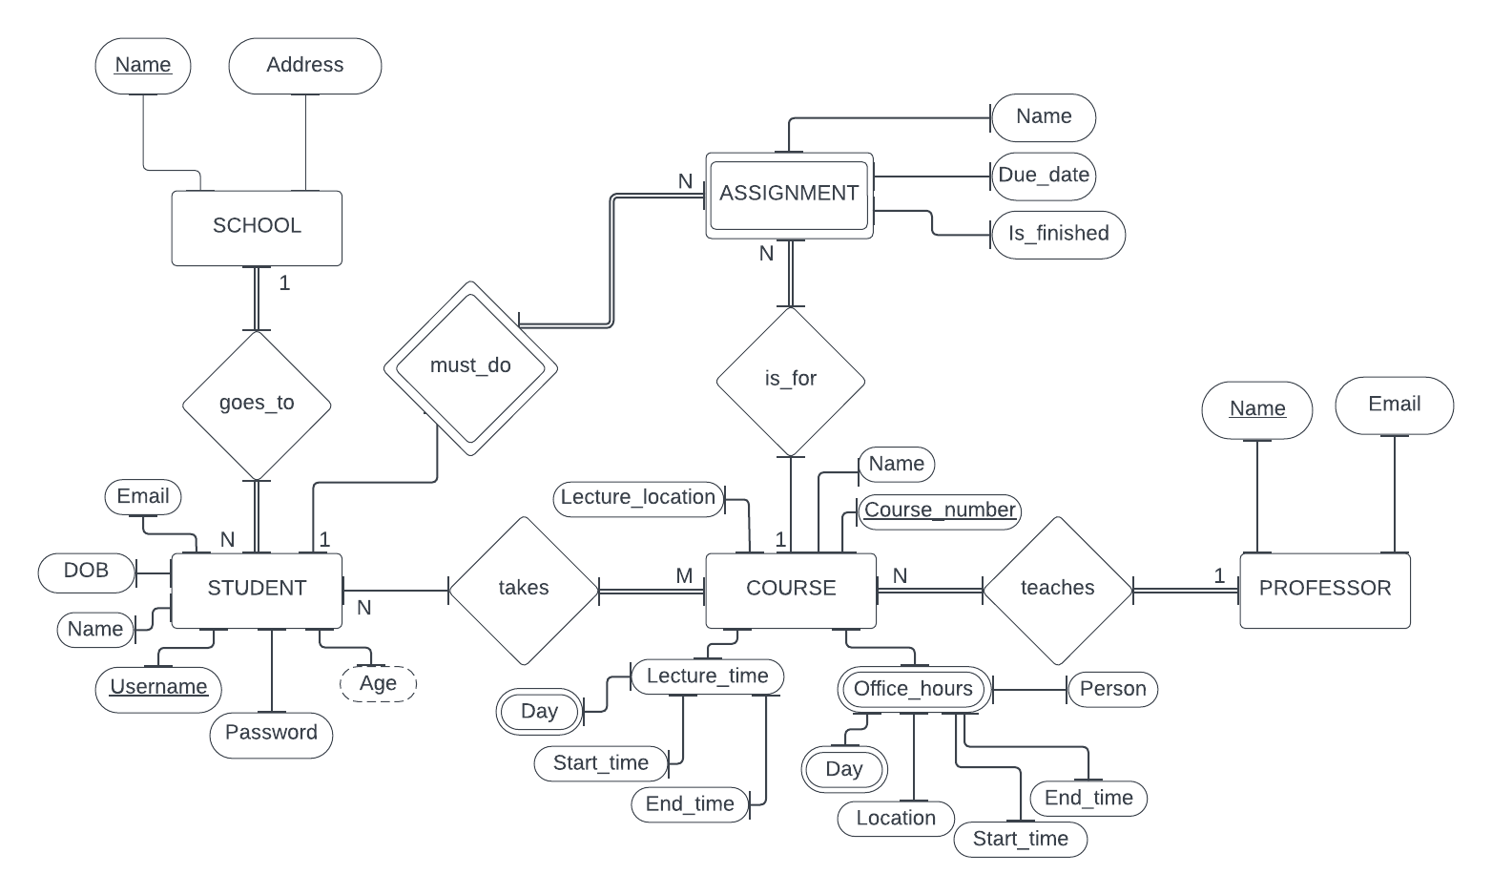

1. Database Functions:
   1. Add a class to a student’s schedule: This would involve checking if the course exists already in the table, and if not adding a new tuple. This would also involve the student entity that stores the student information, as well as the professor entity because the database requires that the course must have a professor. The assignment entity may also be involved, but it is not required like the others.
   2. Mark an assignment as finished: Along with the assignment entity, this would involve the student entity because the assignment is a weak entity type defined by the student.
   3. Adding a new student user: This would of course involve the Student entity. It would also involve the school entity because a student must go to a school in order to be in the database. The course entity might also be involved if the student immediately adds courses, but this is not required like the other two.